**Simple Javascript Calculator:**

UI:

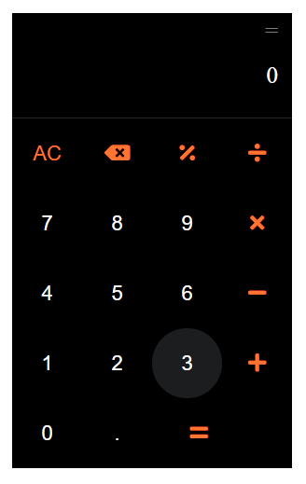

Please note the hover styling on the “3” button. Also, on click of the button, there should be a ripple effect.

The functionality should mimic the functionality of the standard calculator app in mobile phones.

Requirements:

1. Users should be to click the buttons or directly use the keyboard to use the calculator.
2. If they are using keyboard, any keys that are not related the calculator keys should not do anything.

Note: keys for “AC” is “Delete” and  is “Backspace”

1. By default the input should display “0”
2. By default the output should display “=”
3. When user clicks/types any buttons and operations, the input should be displayed, along with the output should show the result(only if the provided input is valid)
4. Pressing “AC” should delete the entire input
5. Pressing “backspace” should remove the last input character.
6. Pressing a number as the initial input should replace the default “0”

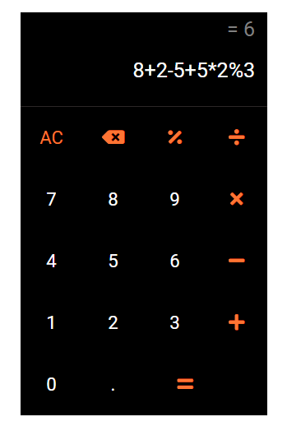

1. When user presses the “=” button on the UI or “=”/”Enter” button on the keyboard, the input should show the result of the operation (if valid) and the output should show the operation performed.

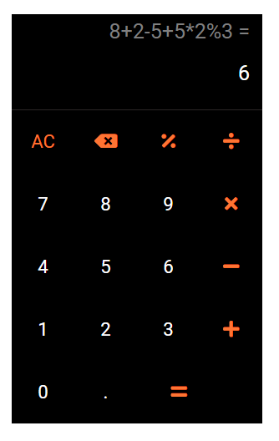

1. User should be able to then continue using the output to perform next operations.
2. If user gives multiple operators that cannot be used simultaneously, the previous operation should be discarded in place of the new operator. Ex: if current input is “3*” and user selects “/”, the input should be become “3/”. Please not that “3*-2” is a VALID operation.

Example of valid input:

* 3+2
* 0.5+0.3
* 5*5/5%5+5-5

Example of Invalid Input:

* 3+
* 3**
* /
* 3+3-
* 9%0
* Validate various operations on the mobile phone’s calculator app

Output:

1. PR from a public github repo for review.
2. Calculator app link hosted using github pages.

Demo: <https://drive.google.com/file/d/1Vq_xqSupudPQn_-LDoUzG69Pvf5LSxY9/view?usp=sharing>